Comprehensive Incentives for Reducing Chinook Salmon Bycatch in the Bering Sea Pollock Fleet: Individual Tradable Encounter Credits

Hao Ye

Scripps Institution of Oceanography, University of California San Diego,
9500 Gilman Drive, La Jolla CA, 92093, USA

e-mail: hye@ucsd.edu

Keith R. Criddle

Ted Stevens Professor of Marine Policy

School of Fisheries and Ocean Science, University of Alaska Fairbanks,
17101 Pt. Lena Loop Road, Juneau, AK 99801, USA

e-mail: kcriddle@sfos.uaf.edu

George Sugihara*

McQuown Chair Professor of Natural Science

Scripps Institution of Oceanography, University of California San Diego,
9500 Gilman Drive, La Jolla CA, 92093, USA

e-mail: gsugihara@ucsd.edu

Abstract Concern about recent bycatches of Chinook salmon (Oncorhynchus tshawytscha) in the Eastern Bering Sea pollock (Theragra chalcogramma) fishery has led to the imposition of a bycatch cap effective 2011—if the cap is exceeded, the fishery will be closed. The hard limit on Chinook salmon bycatch threatens to ignite a race-for-fish in what is currently a highly profitable share-based fishery. A hard cap also has perverse consequences for Chinook salmon by being most restrictive when salmon are relatively abundant and least restrictive when salmon are less abundant and in greatest need of protection. Here we show that a comprehensive incentive plan involving the allocation and trading of a particular form of individual bycatch quota, the Individual Tradable Encounter Credit (ITEC), aligns economic incentives to protect Chinook salmon even when the hard cap is not binding, while concurrently minimizing the cost to industry of avoiding Chinook salmon. Under this plan, incentives for bycatch avoidance are strongest when salmon encounters are least frequent, and reflect the true cost of salmon bycatch.

Keywords: Salmon bycatch, Pollock fishery, Market-based incentives, Individual Tradable Encounter Credits

JEL Classification Codes: Q22, H23, Q28

Introduction
The BSAI Pollock Fishery:
The Eastern Bering Sea and Aleutian Islands (BSAI) fishery for pollock (Theragra chalcogramma) yields gross exvessel revenues in excess of $300 million and a first wholesale value over $1 billion (Hiatt et al., 2008); it is, arguably, the premier U.S. fishery. Over time, this fishery has slowly been rationalized, with the last major change occurring in 1998 with the passage of the American Fisheries Act (AFA 1998). This regulation established permanent sector allocations of the total allowable catch (TAC) in addition to placing a moratorium on the entry of new vessels, setting parameters for the formation of cooperatives within sectors, and provided funds to buy out nine of the twenty-nine then active catcher-processors. All sectors quickly organized under intercooperative agreements—civil contracts—that created sub-sector allocations to each firm. Sub-sector allocations share many of the characteristics of individual fishing quotas (IFQs): they represent an assured opportunity to harvest a known fraction of the TAC and they can be sold or leased within their sector. Since implementation of the intercooperative agreements, the catcher boat and catcher processor fleets have consolidated and become more economically efficient, utilization rates (pounds of finished product per pound of fish caught) have increased, production has shifted towards higher-value product forms, and economic returns have increased (Criddle and Macinko 2000; Anderson 2002; Felthoven 2002; NPFMC 2002; Wilen and Richardson 2008).

Chinook Salmon Bycatch
The pollock fishery uses mid-water trawls to target schools of pollock. This fishery has very low bycatch rates (e.g., 1.1% by weight in 2006 and 1.2% by weight in 2007) and even lower discard rates (e.g., 0.28% in 2006 and 0.30% in 2007) (Hiatt et al. 2008). Nevertheless, the magnitude of pollock catches is so large that even small bycatch rates represent substantial levels of bycatch mortality. In 2007, for example, bycatch mortality included 264 mt of halibut (Hippoglossus stenolepis), 338 mt of herring (Clupea pallasi), 3.8 thousand crabs (Paralithodes sp., Chionoecetes sp., and Lithodes sp.), 109.1 thousand Chinook salmon (Oncorhynchus tshawytscha), and 83.3 thousand other salmon (O. sp.) (Hiatt et al. 2008). Figure 1 depicts the recent history of Chinook salmon bycatch in the BSAI pollock fishery during the A-season (January, February, March) and B-season (June, July, August, September).
Measures to control Chinook salmon bycatch date back to the early 1980s when an overall cap of 55,250 Chinook salmon was set for foreign and joint-venture trawl fisheries (NPFMC 1982, NPFMC 1983, NPFMC 1984). Fixed portions of the overall cap were allocated to each nation licensed to operate in the fishery; any nation that exceeded its annual cap was prohibited from fishing in large parts of the Bering Sea for the remainder of that year. Rather than extend the fixed cap to the domestic fisheries that subsequently displaced the joint-ventures, the NPFMC explored a variety of fixed and triggered spatial closures (NMFS 1995, NMFS 1999, NPFMC 2005). Failure of these measures to avert the large bycatches observed in 2005, 2006, and 2007 provided the impetus for readoption of an annual hard cap on Chinook salmon bycatch mortality (NPFMC 2008).

The PPA
The Preliminary Preferred Alternative (PPA) selected by the NPFMC in April 2009 and submitted for approval by the Secretary of Commerce specifies a framework under which one of two binding caps would apply and specifies how those caps will be apportioned among the sectors and conditions under which they could be apportioned within sectors (NPFMC 2009). NPFMC recommendations are advisory to the Secretary of Commerce who approves or disapproves the proposed changes to established Fishery Management Plans. It is anticipated that the PPA will be implemented in January 2011.
The PPA apportions 70% of the bycatch cap to the A season (January 20 – June 10) and 30% to the B season (June 11 – December 31). During the A-season, catcher-processors will be allocated 32.9% of the A-season cap, motherships will be allocated 8%, shore-based catcher boats will be allocated 49.8%, and CDQ entities will be allocated 9.3%. During the B-season, catcher-processors will be allocated 17.9%, motherships will be allocated 7.3%, shore-based catcher boats will be allocated 69.3% and CDQ entities will be allocated 5.5%. Although these sector allocations are primarily (75%) based on sector bycatch history (2002-2006), they also reflect pollock allocations under the AFA; in effect, sectors with “dirty” fishing history received a somewhat smaller bycatch allocation than their proportionate share of historical bycatch. The PPA provides fishery participants with an opportunity to choose between a simple hard cap of 47,591 Chinook salmon (approximately 39,101 adult equivalents) and a less restrictive cap of 60,000 Chinook salmon (approximately 49,296 adult equivalents) accompanied by the adoption of an intercooperative agreement (ICA) that creates individual vessel-level incentives to avoid bycatch even when the cap is non-binding. The PPA also stipulates that the average annual bycatch be less than 47,591 in at least 4 of every 7 years and includes a provision under which vessels that opt out of the ICA face an open access bycatch pool equivalent to their share of an overall hard cap of 28,496 Chinook salmon. All unused A-season bycatch allowances can roll into the B-season cap.

ICA Requirements:
To operate under the ICA hard cap level, sectors or groups of vessels within a sector must prepare a NOAA-Fisheries approved ICA that demonstrates the following attributes: 1) it rewards individual vessels that successfully avoid Chinook salmon or penalizes individual vessels that fail to avoid Chinook salmon; 2) it creates incentives to avoid Chinook salmon bycatch at all levels of abundance in all years; and, 3) it creates incentives that will influence fishing decisions even when bycatch is at levels below the hard cap. These requirements were established to address several unintended negative outcomes that result when restrictive hard caps alone are used for managing fishery bycatch (Boyce 1996, Abbott & Wilen 2009). For example, a fleet wide hard cap with no individual vessel incentives to avoid bycatch can induce a careless race to fish until the bycatch hard cap is hit, thereby jeopardizing the profitability of the fleet. Strict limits on turtle bycatch forced the early closure of the Hawaiian swordfish fleet in 2006 that resulted in significant revenue loss (Sugihara 2007). Outcomes that are injurious to both the target fishery and bycatch species occur when the prohibited species catch exhibits wide variation in numbers from year to year, such as with Chinook salmon bycatch in the Bering Sea pollock fishery. Insofar as bycatch rates are crude proxies for abundance, a restrictive hard cap will protect Chinook salmon populations exactly when high encounter rates suggest that they are abundant and in least need of protection yet offers no protection when low encounter rates suggest that Chinook salmon populations are low and vulnerable to overexploitation. Ironically, simple hard caps may create a perverse incentive during times of low abundance by encouraging intentional targeting of rare Chinook salmon in order to reduce the future impact of the bycatch hard cap. Clearly, additional mechanisms such as those spelled out in the ICA requirements are needed to protect Chinook salmon and maintain profitability and efficiency within the pollock fishery.

A Comprehensive Incentive Plan for Bycatch Avoidance:
In this paper, we present a comprehensive bycatch credits allocation and trading plan—the Comprehensive Incentive Plan (CIP)—using individual (vessel-level) tradable encounter credits (ITEC) that specifically addresses the incentive requirements of the PPA. This approach provides robust vessel-level incentives to reduce Chinook salmon bycatch under all levels of pollock biomass and at any rate of Chinook salmon bycatch. Additionally, it acts cumulatively through time to provide incentive for continually reducing overall Chinook salmon encounter rates in successive years. The plan is flexible, and with experimental implementation and monitoring can be tuned to meet predetermined performance standards. It shares some elements with well-established pollution credits trading schemes by rewarding vessels with consistently low bycatch rates and penalizing those with chronic high bycatch rates; however, the plan is structured so that the avoidance incentive is greatest during low encounter periods and reflects the actual industry cost of bycatch as determined by the market price for ITEC.

The incentive plan to reduce Chinook salmon bycatch examined here is analogous to regional pollution credit markets in its use of credits trading to create short-term individual vessel incentives to reduce Chinook encounter rates. However, stronger individual incentives come from an annual allocation scheme for ITEC that creates long-term accountability for bycatch behavior. These allocation incentives promote responsible behavior, are cumulative, and operate at all levels of salmon encounter (as required under the PPA). Most significantly, the incentives for bycatch avoidance are strongest at low levels of salmon encounter: times when Chinook populations may be most vulnerable.
This analysis will focus on the inshore catcher-vessel sector using daily data on pollock harvests and Chinook salmon encounters from 2000-2007. These data show that without behavioral changes, vessels will run out of credits under the simple hard cap even in low abundance years (Figure 2). If ITEC are expensive or unavailable for sale, the cost of unfished pollock due to a shortage of credits can be considerable (Figure 3). Therefore, in the CIP the best position for a vessel owner to be in is to have sufficient ITEC in reserve to avoid the need to buy credits, and to have the option of gaining extra revenue by selling unused credits. These aims can be accomplished through bycatch avoidance.

Model
Sectors are assumed to receive annual allocations of salmon encounter (bycatch) credits (1 ITEC = 1 Chinook) in amounts as described under the PPA. Within each sector, the ITEC is distributed to individual vessels under intercooperative agreement enacted within co-ops according to a specifically designed uniform allocation rule (the Legacy Allocation Rule) that provides vessel-level incentives to avoid Chinook salmon encounters and explicitly addresses each of the PPA's required performance attributes. It is assumed that vessels can use or trade ITEC within and across sectors to offset salmon bycatch encounters and these transfers of ITEC are moderated by rules (e.g., Dynamic Salmon Savings) that further reinforce PPA performance attributes and prevent potential abuses.
The main objective of the CIP is to create cumulative financial incentives for a fleet-wide reduction of salmon bycatch by creating vessel-level incentives to reduce Chinook salmon bycatch. That is, it minimizes industry losses due to unharvested pollock under a hard cap while encouraging continual competitive evolution toward diminishing overall Chinook salmon bycatch.
The CIP includes a Legacy Allocation component (rules to reallocate ITEC among vessels to address long-term financial incentives) and a Transfer component (rules to regulate ITEC trading between vessels to address both long- and short-term financial incentives). The Legacy Allocation component reallocates ITEC away from vessels with high encounter rates toward cleaner fishing vessels. It creates long-term insurance-like incentives to prevent catastrophic revenue losses that could occur under the PPA hard cap at times of moderate to high Chinook salmon encounter levels. A particular strength of the Legacy Allocation scheme is that the incentives to avoid bycatch are strongest in years of low salmon abundance, when Chinook salmon populations may be at greatest risk. At these times, the value of ITEC measured in tons of pollock per Chinook salmon are highest while the value of ITEC under a simple hard cap would be negligible because the hard cap would not be binding. Legacy-based reallocation resolves this incongruity by allocating future ITEC based on the past record of performance (akin to a grade point average). This cumulative record creates multi-annual accountability, and dampens the effect of occasional chance events (bad luck) that are not due to individual vessel behavior. It emphasizes the behavioral component of vessel bycatch rates and minimizes the effect of chance encounters. Legacy Allocation creates a cumulative incentive for individual vessels (and hence, the fleet) to adopt consistent behaviors to reduce overall bycatch and its associated costs.
The transfer component of the CIP discourages chronic bad players who place a drag on the fleet, reinforces vessel-scale incentives, and keeps the realized bycatch far below the hard cap whenever possible (i.e. through Dynamic Salmon Savings). The transfer component limits the number of credits that a vessel can purchase and significantly reduces the excess supply of credits during low abundance years. It reinforces the long-term incentives of the allocation scheme as well as the short-term incentives (created by trading ITEC) by promoting higher credits prices in times of low encounter rates.
Auxiliary features of the CIP include an industry sponsored research component to monitor and evaluate program efficacy at reducing bycatch as well as to obtain basic information on Chinook salmon population dynamics (e.g., run strength and stock assessments) to better understand the impacts of Chinook salmon bycatch on the viability of Chinook salmon populations and aligned fisheries. The CIP would implement a fixed fishing closure area (currently referred to as the Chinook Conservation Area). In addition, the CIP includes a 2-strikes rule to weed out chronic offenders and a 3% emergency fund saved as a tax by ICA entities to safeguard against genuine bad luck encounters
Auxiliary benefits of the CIP include the establishment of an independent (certified) organized market place for conducting fishery business. This infrastructural cornerstone would likely find support from outside sources. It would represent a significant step forward towards market efficiency and transparency and would be scalable to other bycatch issues and the trading of financial instruments to control risk. In addition, along with transparency this system will provide natural price signals for the value of bycatch, in terms of the risk and costs of forgone pollock when ITEC become limiting. A major strength of this system is that the penalties and rewards are tied naturally to the actual market value of bycatch to the pollock industry.

Model Specification: Basic Elements of the Plan

Initial Sector Allocation:
Sectors are given fixed annual allocations of salmon encounter (bycatch) credits (1 ITEC = 1 Chinook salmon) in amounts as described in the ICA alternative of the PPA under the industry-wide hard cap of 60,000. For this analysis, the inshore catcher-vessel sector receives 33,390 credits, of which 20,916 are reserved for the A-season and 12,474 credits are reserved until the start of the B-season.

Legacy Vessel Allocation: (a key element)
Individual vessel allocations of ITEC are made separately for each season (A and B-season computed separately) and it is assumed that 100% of any remaining A-season credits are carried forward to the B-season. A 100% carry-forward rule creates incentive to avoid bycatch in the A-season and keeps ITEC prices high at the end of A-season because of the uncertainty in bycatch levels that will occur in the B season. As is evident in Figure 1, B-season Chinook salmon bycatch can be substantial, particularly late in the season (NPFMC 2008). The carryover builds additional incentive for careful fishing (conservation of ITEC) in the A-season, by providing additional insurance for completing the B-season pollock harvest. As discussed below, careful fishing in the B-season is incentivized mainly by the Legacy Allocation scheme as well as by the rewards and penalties associated with trading ITEC.
A key provision of the CIP is the legacy allocation rule, which rewards vessels with low Chinook salmon encounter rates by reallocating extra encounter credits in future years, and penalizes vessels with high encounter rates by reallocating fewer encounter credits in the following years. This creates several different incentives to lower bycatch, including having extra credits as insurance against future moderate to high salmon abundance years. At these times, additional ITEC are likely to be needed to finish harvesting one’s pollock allocation and few ITEC will be available for purchase because other operators will have similarly large bycatch rates. The cost of unfished pollock due to a shortage of credits can be considerable (Figure 3). The allocation scheme uses these potential costs as incentive for individual vessels to reduce salmon bycatch in order to obtain a maximal reserve of credits.
There are many possible implementations of the legacy allocation rule. Indeed, any rule that provides additional credits as reward for low bycatch rates penalizes high bycatch rates with fewer credits, and where these rewards and penalties carry forward from year to year will suffice. In our plan, we consider the following allocation scheme: at the start of each season, credits are distributed to the individual vessels according to a formula that takes three factors into account for each vessel:
- Pollock quota for the season
- Previous year’s proportional allocation factor for the season (season specific legacy)
- Previous year’s relative bycatch rate for the season (season specific bycatch)

The amount of ITEC a vessel receives is as follows:
C_{s, y ,i} = P_{s, y, i} F_{s, y, i} I_{s} (1)
Where C_{s, y ,i} is the number of credits that vessel i receives for season s (i.e., A-season or B-season) of year y. P_{s, y ,i} is the proportional allocation factor (equation 2 below), F_{s, y ,i} is the AFA cooperative catch share (fraction of the sector’s pollock quota) received by vessel i in season s of year y, and 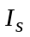 is the total amount of ITEC for the sector in season s, as described in the PPA.
The proportional allocation factor for each vessel is updated according to:
P_{s, y, i} = α + βP_{s, y-1, i} + γQ_{s, y-1, i} (2)
where P_{s, y-1 ,i} is the proportional allocation factor for vessel i for season s of year y-1. The constants α, β and γ are proportional weights that sum to unity (see Appendix A for a more detailed discussion). The first term α serves as a fixed constant, the second term β is the weight given to the previous year’s proportional allocation factor, P_{s, y-1 ,i} (the “legacy” term), and γ is the weight given to the bycatch function Q_{s, y-1 ,i}, which can assume any sensible monotonic form that penalizes high bycatch rates. Due to the form of equation (2), values of Q > 1 will increase a vessel’s proportional allocation factor, while values of Q < 1 will decrease a vessel’s proportional allocation factor. A particularly nice property of this formula is the presence of asymptotic upper and lower bounds for P that constrain how far the proportional allocations for any vessel can differ from their initial allocation.
The proportional allocation factor reflects a vessel’s allocation relative to its initial allocation. During the first year of implementation, the proportional allocation factor for each vessel is unity. Thus, all vessels within a cooperative governed by an ICA would receive an ITEC allocation pro rata to their pollock allocations. In subsequent years, this proportional allocation factor will change (based on bycatch performance) and individual vessels will receive differing ITEC allocations. For vessels with the same pollock allocation, the relative values of their proportional allocation factors will reflect their relative ITEC allocations: if one vessel’s proportional allocation factor is 20% larger than the other vessel, it will receive 20% more credits than the other vessel (again, assuming that both vessels receive the same pollock allocation).
The formula in equation (2) is presented in a generic and flexible form to emphasize the fact that with monitoring and feedback, the parameters can be tuned to effect different magnitudes of bycatch reduction to meet performance standards. We note, however that the actual magnitude of bycatch reduction produced by any plan involving complex human behavior cannot be known ex ante, except by experimental implementation. We will return to this issue in the section on “Hypothetical Modeling of Incentives,” where we present a heuristic simulation based on plausible estimates of changes in bycatch behavior in response to incentives in the CIP.

Example Parameterization:
Here we will consider the specific case where the bycatch function is linear of the form Q_{s, y-1 ,I} = δ + εp_{i} where δ and ε are constants and p_{i} is the penalty value for vessel i computed via a penalty function dependent upon the relative bycatch rate, such that vessels with a lower than average bycatch rate will have Q > 1, and vessels with a higher than average bycatch rate will have Q < 1. Thus, vessels that have lower than average bycatch rate will see an initial increase in ITEC allocation, and vessels with higher than average bycatch rate will see an initial decrease in ITEC allocation (See Appendix A for a detailed description of calculations).
Two different weighting schemes will be considered that alter the importance of the legacy component: when α = β = γ = 1/3 (equal weighting) and α = γ = 1/4 and β = 1/2 (augmented legacy weighting), and where δ = 1/3 and ε = 4/3. That is, we will consider
P_{s, y, i} = (1/3) + (1/3)P_{s, y-1, i} + (1/3)Q_{s, y-1, i} (3)
or the (1/3,1/3,1/3) “equal” weighting and,
P_{s, y, i} = (1/4) + (1/2)P_{s, y-1, i} + (1/4)Q_{s, y-1, i} (4)
or the (1/4,1/2,1/4) “augmented legacy” weighting.
Both of these weighting schemes have a lower bound of 2/3 relative to the initial allocation and an upper bound of 4/3. This means that in both formulas (3) and (4) no vessel can lose more than 1/3 of its initial allocation or gain more than 1/3. A range of 2/3 in the proportional allocation factor is reckoned to provide sufficient motivation for the incentives to be effective, however this can be adjusted as necessary (See Appendix A for a discussion of bounds and weighting formulas). These specific bounds [2/3,4/3] are the lower and upper bounds recommended to industry, along with augmented legacy weighting.
Most of the analyses here are based on the augmented legacy model (equation 4). Except for the speed of convergence (speed at which it is possible to recover from a low ranking) the results here do not differ qualitatively from results using equation (3) (see Appendix A-5 for a discussion of convergence). Indeed, equation (3) may be preferable in some cases as discussed below. In particular, a higher weight given to the legacy component is a way to minimize the random effects of sampling error in bycatch rates (bad luck encounters) and emphasize the more consistent intentional behavioral component of variation in bycatch rates among vessels. Because the year-to-year changes are smaller, vessels must do consistently well (i.e., lower bycatch) in order to obtain the maximum possible increase in ITEC allocation. Similarly, vessels which initially have high bycatch are given more opportunities to improve over time. That is, a larger β in equation (1) helps to sort out the behavioral component from the chance component in determining relative seasonal ITEC allocations (penalties and rewards). However, the smaller value for γ creates less yearly incentive to reduce bycatch, as the year by year changes in proportional allocation factor will be smaller. One must balance these two factors in arriving at a final model. As a starting point we suggest the augmented legacy weighting (1/4,1/2,1/4), and unless otherwise stated, this weighting will be used in our analysis.
Again, it is assumed that these allocation factors are computed separately for each season and that there is 100% carry forward of remainder credits from the A-season to the B-season. In practice, a running tab will be kept to let each vessel know in real-time where it stands with respect to the “expectation” of next year's proportional allocation factor. This way there are no surprises and individual vessels will have more motivation to reduce bycatch because they can adjust behavior mid-season in response to competition between vessels to maximize future ITEC allocations. Each vessel can know where it stands “on the fly” relative to the sector (presumably only the data on fleet-wide bycatch will be available to each vessel, with individual vessel performance remaining private information).
The incentives created by the cumulative nature of the Legacy Allocation model provide continual incentive to reduce bycatch and promote consistent good behavior. Thus, if a vessel is near the top of the pack, then it will remain near the top of the pack only if it consistently continues to perform well relative to the fleet. If a vessel at the top of the pack has an average year (middle of the pack), it will lose some credits in the subsequent reallocation. It is not possible for vessels to slack off and maintain an augmented ITEC allocation. Incentives are always present (from year 1 onwards). This also means that there is consistent vessel-level incentive for improvement—because credits are transferred from vessels with high bycatch rates to cleaner vessels through reallocation, the bycatch rates for the fleet as a whole continuously ameliorate.
Conversely, if a vessel is at the bottom of the pack in terms of bycatch avoidance, it will remain there only if it stays at the bottom relative to other vessels in each year. It can dig out of this hole by consistently moving its behavior closer to the mean. The constant competition and a cumulative record of vessel competitiveness will stimulate a steady decline in the industry average bycatch rate.
Because of the large variability in Chinook salmon abundance, even vessels at the asymptotic lower limit of ITEC allocation may not be forced to forego a portion of their pollock allocation every year. However, this should not be viewed as a flaw in the legacy plan. These vessels will likely lose a large amount of potential revenue in mid- and high-encounter years. Few credits will be available for trade during these times, so vessels that have exhausted their ITEC will be unable to simply purchase more credits to continue fishing pollock. The only reasonable options for these vessels (to avoid revenue losses) are to improve their allocation by reducing their bycatch rates or to sell their pollock shares (AFA allocation) and associated ITEC to a cleaner vessel. Due to the nature of the plan, this can be accomplished even with small changes in bycatch rates: such a vessel would not need to reduce bycatch dramatically to see improvements in ITEC allocation (but larger reductions in bycatch would result in larger increases in ITEC allocation). Thus, these vessels are incentivized to reduce bycatch in all years, even when their allocations may not be binding.
Another option to deal with the worst offenders is to consider some sort of special rule (see Appendix D-2), which might prohibit vessels that are the worst offenders in consecutive years from purchasing any credits. These rules may provide additional incentives for vessels that may be initially unresponsive to the incentives laid out in the legacy plan.

A “False Legacy” Model:
To further clarify how Legacy allocation works, it is useful to consider a degenerate case of the general Legacy Allocation formula, equation 1, that occurs when α = 0 and β = γ = 1, which no longer has the desired legacy behavior:
P_{s, y, i} = P_{s, y-1, i} + Q_{s, y-1, i} (5)
Here the relative legacy-term weight is adjusted via the bycatch function, Q, which will have a different form than discussed above. Equation (5) describes a simple random walk where the proportional allocation factor P_{y}, depends only on the last value P_{y-1}, and the bycatch term, Q, which is simply a random variable. Unfortunately, this simple random walk formula for credit allocations lacks the desirable property of asymptotic bounds—it can increase or decrease indefinitely (and even go negative). However one can implement an ad-hoc patch to this problem by setting arbitrary limits on P (e.g., hard limits of [2/3,4/3] as effective absorbing bounds to the random walk).
The cost associated with the lack of convergence to natural limits is that equation (5) is not really a legacy system in terms of the way incentives work, nor in terms of separating out the behavioral component from the chance component. It lacks all of the interesting strengths that make a true Legacy system work. For example, vessels that are at the upper limit of credit allocation will remain there, even after years where their bycatch rate is merely average. There is no further incentive to improve beyond achieving the average bycatch rate. Similarly, vessels that are at the lower limit of credit allocation will not experience an increase in allocation, even if their bycatch rate is average (middle of the pack). Thus the realistic strategy for “dirty” vessels is to stay “dirty”. In other words, once you become an A student you remain an A student even if you perform like a C student from then on, and once an F student, you remain there even if you consistently perform like a C student. A consistent C student can get rewarded in perpetuity as an A student or and F student. There is a mismatch between current actions and consequences—it is a degenerate case that will produce a distribution of allocations that is flat with spikes at either end. Asymptotic (gradual) convergence to intrinsic upper and lower bounds (e.g., 2/3,4/3) is essential to have sensible incentives (e.g., consistent good behavior etc).
Although equation (5) lacks the sensible cumulative incentive dynamics associated with equations (3) or (4), it is not without merit. Namely, it is easy to explain and adjust in ad-hoc ways, and is therefore likely to be useful in non-technically guided discussions about specific parameter implementations. For example, it is possible to specify a rapid linear (non-asymptotic) approach to a boundary. Thus, the limits on Q could be set so that a lower-bound can be hit in three years, giving rise to a “3-strikes rule” so that the consistent worst case performer hits the lower limit (e.g., P = 2/3) in 3 years starting from the initial allocation. Here, the penalty for being the worst performing vessel is equal for all 3 years (e.g., -11.1%) rather than in progressively smaller increments (see Appendix A for details) as the vessel approaches the lower-bound in the more general case (e.g., equation 2).

Scaling for Vessel Size to Place Small Independent Vessels on a level Playing Ground with Large Vessels and Firms
The variance in bycatch rates between vessels can be attributed, in part, to chance encounters with patchy dense pockets of Chinook salmon, which is related in part to sample size effects or sampling variation. This, in turn, is directly related to vessel size. Consequently, as shown in Figure 4, the variance in bycatch rates of smaller vessels in the inshore sector is systematically higher than that for larger vessels. That is, small vessels suffer greater risk of completing a season with an overall bycatch rate that is inflated by the occurrence of an unusually “dirty” tow—larger vessels or companies with multiple vessels can average such unusual hauls over a large number of total hauls and thereby diminish the influence of unusual observations on the overall seasonal bycatch tally. Because small vessels are subject to more sampling error of this kind, we used a corrected standard deviation in the allocation calculation to adjust for the effects of random noise due to vessel size (see Appendix A for details). This random noise varies with the inverse square root of 1 + pollock allocation % and is applied to put small independent vessels on the same level playing ground with respect to legacy allocations as larger vessels and companies that employ many vessels. It is a minor but measureable correction on reallocation that removes the disadvantage of increased risk experienced by smaller vessels.

Scaling to Avoid Penalizing Competitive Improvement Through Time
In addition to various forms of sampling variation, the variance in bycatch rates between vessels can also be attributed, in part, to consistent behaviors shown by vessels that appear to directly influence bycatch rates (caution in gear deployment, choices of fishing location, tow speed, timing, etc.).
One reasonable expectation of the CIP is that the variance in the distribution of bycatch rates among vessels will decrease over time as vessels adopt bycatch reducing operational strategies. As this happens, bycatch rates will fall and an increased proportion of the variation in bycatch rates will be due to random chance rather than operational choices of individual vessels. Indeed, as shown in Figure 5 for all of the sectors combined, there is a clear tendency for lower variance in bycatch rate to accompany a lower sector bycatch rate, reinforcing the idea of a narrower distribution of rates accompanying lowered rates. This suggests rescaling variances to keep a level playing field (see Appendix A for details).
This scaled variance is intended as a simple correction for the fact that with time the variance in bycatch rates should decline, meaning that the effects of equivalent random variation on subsequent allocations will grow. Basically, this rule keeps reallocations of ITEC from increasing artificially as the variance in bycatch distributions falls through time. Without any scaling, as the distribution of bycatch rates within a sector becomes narrower, vessels would see larger changes in ITEC allocation for the same magnitude of changes in bycatch rates. This scaling was implemented in the CIP to ensure that variance in relative bycatch rate continues to reflect behavioral differences rather than noise even as the fleet converges to lower bycatch rates. There is some concern that vessels will be punished or rewarded due to chance encounters when the distribution of bycatch rates for the fleet becomes narrow. Rather than thinking of this as “diluting” incentives, it is better to think of this as preventing the potential artificial amplification of the effects of random chance due to systematic declines in variance

Legacy Incentives with this parameterization
Given the specific bounds [2/3,4/3], the magnitude of the financial incentives created by Legacy Allocations can be large in terms of the value of pollock quota left unharvested when vessels run out of ITEC and credits are not readily available for sale.
A vessel that fishes cleaner can realize more value per Chinook salmon bycaught. Likewise, a less skillful vessel with high encounter rates realizes less value. Thus, ITEC has a higher intrinsic value to a cleaner vessel than to one with high encounter rates. In the short term, clean vessels will be net sellers of ITEC or net buyers of pollock catch shares and will perceive a higher value, while vessels with high bycatch rates will be net buyers of ITEC or sellers of pollock catch shares. The allocation scheme steadily puts more ITEC in the hands of cleaner vessels so that overall fleet bycatch will decline with time.

Transfer Rules

ITEC Supply and Pricing Considerations:
The price of encounter credits will be determined by market perceptions of supply and demand and these in turn will be driven mainly by the perceived risk of running out of ITEC or of needing one’s full complement of ITEC to finish the season. Because this uncertainty is greatest at the beginning of the season, the price of ITEC is likely to be highest at that time. ITEC will generally be unavailable for sale early in the season. Indeed, vessels are likely to offer ITEC for sale only after completing their pollock harvest, when there is no risk of running out of credits and experiencing its associated costs.
As individual vessel owners become willing sellers of surplus ITEC once their pollock quota is harvested, the supply of ITEC will increase which will put downward pressure on ITEC prices toward the end of the season. During times of moderate to high Chinook salmon encounters, this rising supply will be met with rising demand and prices could actually increase toward the end of the season. However, during times of low encounters this could result in a glut of ITEC at the end of the season. The potential for an end-of-season glut could cause a drop in ITEC prices, and a reduction in short-term incentives, paving the way for abuse (i.e. diminished incentives to reduce bycatch). Thus, transfer rules are required to regulate the demand for and supply of ITEC.
We examine two types of transfer rules for ITEC: “Buy side” transfer rules and “Sell side” transfer rules (fixed tax on transfers vs. dynamic salmon savings). We recommend that the best outcome is likely to come from using both kinds of transfer rules together to support incentives for Chinook salmon bycatch avoidance, especially during times of low salmon encounters.

Buy Side Transfer Limits:
So that a poorly performing vessel (one at the 2/3 allocation level) can never obtain more than its original allocation through purchase we recommend the following buy side transfer limit: “in each season only an amount less than 1/3 of a vessel’s credits allocation for that season may be purchased.” This means that the worst performers (with lower allocations) will be able to buy fewer credits, while the better performers, with larger initial allocations, are further rewarded with the ability to potentially buy more if needed. This fixed buy-side transfer limit is simple to implement and should not affect the profitability of the sector but is likely to encourage the transfer of pollock catch shares to “clean” boats rather than transfer of ITEC to vessels with high bycatch rates.
The benefits of this simple rule are that:
- It addresses individual vessel incentives (a requirement of the ICA alternative in the PPA).
- It addresses the possible abuse of abundant ITEC during low salmon abundance years. (a requirement of the ICA alternative in the PPA by influencing decisions at levels well below the hard cap)
- It will not affect the completion of pollock harvest (as shown in historical simulations)
- It reinforces the incentives provided by the legacy allocation system because vessel ITEC allocations (P) and buy side limits move in tandem. (a requirement of the ICA alternative in the PPA: reward vessels that avoid bycatch and penalize those that do not)
- Insofar as it depends on the allocation proportion factor, P, the buy-side limit is more vulnerable to readjustment during times of low salmon abundance, strengthening incentive to reduce bycatch. (A requirement of the ICA alternative in the PPA: create incentives at all levels of abundance in all years.)
- It provides additional incentives for the worst performing vessels to reduce bycatch, in order to increase their proportional allocation factor and enable the purchases of additional credits. (a requirement of the ICA alternative in the PPA)

Again, a buy side transfer limit means that the worst performers (those with lower allocations) can buy fewer credits. Thus, it resonates with the legacy system, and it augments incentive for salmon avoidance during periods of low encounters.

Sell Side Transfer Limits: (Dynamic Salmon Savings)

Fixed Transfer Tax:
A fixed sell-side transfer tax is not desirable to industry as it can potentially limit the pollock harvest. Neither is it desirable to Chinook salmon conservation as it is dependent upon transfers taking place. During years of low salmon encounter, very few transfers will take place, reducing the effectiveness of a fixed transfer tax exactly when it is most needed. Conversely, transfers of ITEC occur more frequently and in greater volume during years of moderate to high salmon encounter; at these times, a fixed transfer tax will increase the burden of an already limited ITEC supply. Such times are when credits are most needed by the pollock industry. Fixed transfer taxes are not a good fit to this problem.

Dynamic Salmon Savings (DSS):
Thus, we suggest a Dynamic Salmon Savings rule that is adaptive to different levels of salmon encounter and will apply to each vessel after it completes its pollock harvest. This is more complicated to implement, but more desirable to Chinook salmon interests than a buy side rule alone or a fixed tax, as it represents a true salmon savings rule that creates much more protection for Chinook salmon during times of low encounters.
The Dynamic Salmon Savings rule imposes a constraint on the “sell” side of transfers. It includes a sector specific “salmon savings rate” (SSR) that is applied to each vessel’s surplus ITEC. Surplus credits include the remainder of a vessel’s credits left after filling its B-season quota and any credits sold prior to filling its quota. The sector specific SSR calculated near the end of the B-season should: address the possible abuse of abundant encounter credits during low salmon abundance years; not adversely affect the completion of pollock harvest; and, be a function of Chinook salmon abundance.
The Dynamic Salmon Savings rule consists of two parts. The first part is a provisional savings rule that applies to vessels that sell credits before they finish fishing in the B-season. The provisional savings rule requires that ITEC savings must be held in reserve to meet the maximum SSR. This promotes salmon savings early in the year. The second part is determination of a valid SSR far enough in advance of the end of the season to be useful. SSR is the fraction of surplus ITEC that must be retired when a vessel completes its fishing. Surplus ITEC are credits that a vessel did not use to fish its full quota of pollock.
Prior to setting the SSR, transfers would be allowed, but only up to some fixed percentage of a seller’s residual ITEC, the quantity of ITEC that a seller wishes to sell. Residual ITEC includes carry-forward from the A-season. The provisional savings rule would require that vessels selling ITEC early must have a reserve of credits set aside to accommodate the largest possible SSR. It acts as a withholding tax for residual credits.
For example, if a cap is set so that the maximum SSR is 50% (a number that would not have limited historical harvests), then prior to setting the dynamic savings rule (e.g., throughout the A-season), boats that have finished fishing early can only sell up to 50% of their residual ITEC. The provisional SSR would also be 50%, or the maximum SSR. Thus, if a vessel wishes to sell 50 credits early in the year, it must keep 50 ITEC in reserve until the SSR is calculated. This reserve acts as a de facto conservative salmon savings rule governing transfers until the SSR is posted. It operates like “tax withholding” and protects (holds ITEC in reserve) a large fraction of salmon until the SSR is posted.
A provisional savings rule prevents potential abuses that would occur otherwise when vessels sell ITEC before they “finish” fishing. Since ITEC would not be retired until a vessel “completes” fishing, a vessel could sell all of its credits before fishing its complete pollock allocation as a strategy to avoid having ITEC retired. A provisional savings rule prevents this exploitation by requiring that the appropriate ratio of credits be set in reserve for each transfer that occurs before a vessel finishes fishing or before the SSR is set (as in the preceding example).
Numerical experiments with the Inshore sector daily data over an 8-year period suggest that calculating the SSR when 2/3 of the B-season sector pollock quota are caught (2/3 sector TAC) gives the best result, in terms of estimating the credits needed to complete the season (see Appendix B for details on calculating the SSR). This is the “estimated total sector by-catch for the B-season.” This estimate normally occurs between August 29 and Sept 16 (Appendix B). This tends to happen later in low salmon abundance years (when fewer transfers are needed) and occurs earlier in moderate to high abundance years (see Table B-1).
A dynamic salmon savings rule should increase the effectiveness of a market-incentive plan with regards to protecting Chinook salmon and meeting the PPA ICA alternative performance measure. One of the primary criticisms of the 60,000 hard cap on Chinook salmon bycatch is that it is set too high. This level of hard cap may fail to satisfy the requirement of incentivizing reduced salmon bycatch at all levels of abundance. A lower hard cap is one possible solution. However, historical data show that salmon encounter rates vary over a wide range. A low hard cap can pose significant financial risk for the pollock fishery during years of high salmon encounter (indeed, historic performance suggests that a 60,000 hard cap with a performance target of 47,591 would have created financial risk for some vessels even during years of moderate salmon abundance (see Figure 2). Conversely, a high hard cap would result in excess ITEC (and the potential for abuse) during years of low salmon encounter. The ideal solution to this problem would be to develop methods to accurately forecast salmon abundances and encounter rates. A much more feasible alternative is an adaptive rule, such as Dynamic Salmon Savings (DSS), which is adjusted each year, taking into account that season’s observed level of salmon encounters. Unlike a fixed transfer tax, DSS retires ITEC during times when surplus ITEC is abundant and the potential for abuse is high. A fixed tax can only retire credits when transactions occur. During low-encounter years, few transactions take place (because most vessels have enough credits to fish their own pollock allocation). Thus, a fixed tax will fail to be effective during times of low salmon encounter, precisely when a transfer rule should be most effective.
In our simulations of the number of credits retired under a fixed transfer tax scheme and DSS, we found that DSS retired significantly (over 4 times) more credits over a span of 8 years (2000 - 2007) for the Inshore catcher-vessel sector (Figure 9a). Not only does DSS save more credits than a fixed transfer tax over this 8-year period, but the savings occur during years of low salmon encounter under a DSS scheme (Figure 9b). Details regarding the implementation of both the fixed transfer tax and dynamic salmon savings can be found in Appendix B, along with more detailed simulation results.
One potential issue related to DSS is the estimation of the number of ITEC needed to complete harvests of pollock. Because this is an estimate of the amount of bycatch that the industry might experience for the rest of the season, it has the potential to influence fishing behavior. We believe that it will not adversely affect bycatch rates (i.e., elevating bycatch rates above what they would be without such an estimate). Like all estimates of bycatch, it is subject to error: the large fluctuations in bycatch levels and salmon abundances from year-to-year and season-to-season should make individual vessels cautious about running out of ITEC. Furthermore, although some vessels may become less careful in avoiding bycatch if the estimate of bycatch is high, they can be taken advantage of by vessels that are rigorous in avoiding bycatch. Since vessels are competing with each other for increased allocations, vessels that have lower bycatch relative to other vessels will see increased allocations. The competitive aspect of the legacy plan means that an estimate of bycatch will adversely affect bycatch rates only if all vessels are lax about reducing bycatch. Seeing even one vessel outperform the rest will incite the rest of the fleet to catch up.
Worries that the SSR will limit credit availability towards the end of the B season provides an additional motivating factor for vessels to reduce bycatch, possibly by concentrating effort at the beginning of the B season, when historical bycatch rates have been low. This could have the added feedback effect of increasing the SSR and encouraging other vessels to fish earlier in the B season: by catching more pollock earlier, and at lower bycatch rates, the amount of salmon savings would be set even higher, potentially encouraging more vessels to fish early when bycatch rates are low. One disadvantage to this behavioral change, however, is that it is likely to increase bycatch of chum salmon (O. keta) which is historically higher at the beginning of the B season for pollock. One potential solution to this problem would be to expand the CIP to related fisheries and other bycatch species. Vessels would then be able to trade Chinook salmon ITEC for chum salmon ITEC depending on their intended time of fishing and expectations for bycatch. Additionally, it would give flexibility for individual vessels in the fishery to collectively manage bycatch; by leveraging their relative ability to avoid bycatch of one or the other species (i.e. vessels could concentrate effort in fisheries where they are most effective at avoiding bycatch, resulting in an overall decrease in bycatch not possible if each fishery managed bycatch independently).

Incentives/Issues

Industry costs associated with non-transferability of credits.
Without a transfer mechanism, some individual vessels will run out of ITEC, and a portion of the pollock TAC could go unfished, resulting in significant revenue losses for the pollock industry. These losses could happen even during low to moderate Chinook salmon encounter years. Figure 2 illustrates the timing of how many vessels run out of credits in each season under the proposed Inshore sector hard cap of 33,390 assuming no behavioral change in response to a hard cap (includes 100% A to B carry forward).
What is interesting here is that, in 2000, apparently no vessels would have run out of ITEC (hence no trading would have been required). However, in other low Chinook salmon encounter years (2001, 2002, and 2003) and in the moderate Chinook salmon abundance years (2004 and 2005), a number of vessels would have run out of Chinook salmon encounter credits. This suggests that while no trading would have been required in 2000, that it would have been required in other years for each vessel to finish harvesting its pollock allocation.
The sector revenue loss associated with not being able to trade encounter credits under a hard cap scenario can be considerable. These costs are illustrated in Figure 3, and can exceed $87m in a single year. The risk of catastrophic losses due to unharvested pollock in any given year should provide strong financial motivation for industry to adopt a plan for transferring ITEC, in addition to incentivizing individual vessels to lower bycatch rates so that they may insure themselves against revenue loss (via increased ITEC allocation and/or reduced need for ITEC). Moreover, vessels that may run out of ITEC, even in moderate encounter years, will be incentivized to lower their bycatch rates to make maximal use of their ITEC allocation and to secure a sufficiently high ITEC allocation in subsequent years.
Trading encounter credits even without explicit incentives to avoid bycatch can increase industry revenues and reduce fleet bycatch. Figure 7 illustrates a hypothetical scenario where reallocation (using equation 2) and trading occurs by the following simple rules: ITEC are only traded after a vessel has finished its pollock quota for the season; and ITEC are transferred as soon as they are needed and are made available to the vessel(s) that have run out of ITEC and for whom the intrinsic value (non-market value) is highest–these vessels will be able to offer the highest price for ITEC.
The remarkable thing here is that this shows that there can be significant revenue advantages to credits trading for the sector as a whole, despite the fact that there is no explicit individual motivation to avoid bycatch. Although the effect is modest, the natural dynamics of the allocation scheme and the trading model by itself can enhance revenues, and reduce bycatch for the fleet as a whole.

Infrastructure for Monitoring and Trading ITEC
Perhaps the greatest long term benefit of the ITEC trading and allocation plan is the establishment of an independent (certified) organized market place for conducting fishery business. This infrastructural cornerstone would be likely find support from outside sources and could be an independent Commodities Futures Trading Commission certified contractor such as the Chicago Climate Exchange. Having such certification would bring credibility and would represent a significant step forward toward market efficiency and transparency, and would be scalable to other bycatch issues (e.g. chum salmon), other fisheries (e.g. Pacific whiting) and the trading of financial instruments to control risk.

Handling Transfers Across Sectors
As originally conceived, the CIP would operate throughout an entire sector. However, this is not required. What is required is that trading of ITEC across sectors or subsectors operating under different bycatch incentive programs would be restricted; sectors with Dynamic Salmon Savings can sell credits to any other sector, but may only buy credits from another sector with a Dynamic Salmon Savings rule and the same maximum Salmon Savings Rate. From the point of view of maintaining rational incentives in the CIP the following rules should apply to transfers across groups or sectors that may or may not participate in the plan: (1) unless otherwise regulated, sectors with Dynamic Salmon Savings (DSS) may sell credits to any other sector; (2) unless otherwise regulated, sectors without DSS may buy credits from any other sector; and, (3) a sector with DSS cannot buy credits from a sector without DSS.

Incentives and Issues related to the allocation scheme.
A key incentive mechanism for the tradable encounter credits model is the allocation of credits based on current and past (legacy) encounter rate behavior. As we have already seen (Appendix B) the intrinsic fishery value of ITEC can be very high, and in years of high salmon abundance, the cost of forgone pollock under a Chinook salmon hard cap can represent a catastrophic loss. The possibility of having surplus ITEC increases the value of avoiding current bycatch out of concern that future years could involve moderate to high Chinook salmon abundance. This requires forward thinking similar to buying insurance. Having extra credits reduces the risk of foregone pollock catches or the need to purchase ITEC in years of moderate to high Chinook salmon abundance. The additional revenue per bonus credit in the 2007 A-season (assuming the vessel would have otherwise run out of credits) is on the order of $7k to $20k/ITEC—a strong motivation in terms of opportunity cost.
Of special significance is the fact that this allocation scheme operates more sensitively during years of low salmon abundance (Figure 6). That is, vessels are more strongly rewarded or penalized for fishing behavior during low salmon encounter years. Additionally, the intrinsic fishery value of the credits is higher at times of low salmon abundance (Appendix B).

Incentives related to trading ITEC.
In general, if vessel-owners expect to have surplus ITEC in any given year, they can post it for sale on an electronic market site. This could represent significant extra revenue, especially if there is significant asymmetry in performance among vessels. Alternatively, they could enter into the market to lease or buy additional pollock catch shares from vessels that are at risk of running short of ITEC needed to complete their pollock harvests. Similarly, if a vessel owner needs to buy ITEC, he can do so at the market price or he can offer to lease his pollock catch shares. This incentive structure is similar to the incentives for trading pollution offset credits. However it also involves a Dynamic Salmon Savings (and a maximal withholding tax (PSSR) of 50% on early ITEC sales) to control possible excess supplies of ITEC in periods of low Chinook salmon abundance. Based on experience in the pollution offset credit markets, it can be expected that the long-run result will be a transfer of pollock catch shares from “dirty” boats to “clean” boats rather than a transfer of ITEC from “clean” boats to “dirty” boats. This is because each unit of ITEC is worth more pollock harvests to a “clean” boat than it is to a “dirty” boat. It is not known whether credit pricing will be sufficient to deter chronic bad performers who respond only to current incentives as trading is not always required (e.g., 2000). Monitoring and adjustment will be required (the simulations suggest that a withholding tax of up to 50% can be tolerated without directly harming the pollock harvest). However, these are times where the legacy incentives are strongest. Just as competition between similar products drives down prices and increases production efficiency, CIP utilizes market incentives to increase efficiency (i.e. reduce bycatch) in the fishery.

Legacy Incentives
The second term of the allocation formula (2) is the so-called “legacy” component that incorporates past behavior into the current allocation scheme. This component serves three important functions. First, it moderates the random component in seasonal year-to-year variability in seasonal bycatch that is due to chance, and tends to amplify the behavioral component. One of the problems with any performance related reward/penalty system is that it is almost always subject to randomness in some form. Chance is part of life, but one wants to minimize this as much as possible without also destroying the incentives created by rewarding/penalizing differences in performance. Separating out such random variation in bycatch rates (e.g., sampling error or bad luck), from variation due to operational choices is difficult but is handled somewhat by the Legacy component, which rewards and penalizes consistent behavior. This problem is addressed in the present system in several ways (see Appendix A for a fuller discussion), but it is usually problematic to try to separate natural sampling variation, from variability due to behavior without using historical data that can capture consistent patterns of behavior. Thus, boats in the same area may have different bycatch rates partly due to sampling variation and partly due to operational choices and this is difficult to sort out without assumptions that may be questionable. The legacy component dampens out variation due to accident and tends to highlight variation that results from operational choices.
Second, the legacy system provides carrot and stick incentives for long-term accountability in behavior. It encourages forward thinking and a chance to improve toward the upper bound allocation of 4/3 the initial allocation. It also provides the “stick” of having only 2/3 the initial allocation to fall back on. The catastrophic costs associated with insufficient ITEC represent a strong financial incentive on behavior. The legacy system makes the full hard cap available to the fleet only when it is absolutely necessary, but at the same time it provides strong financial and competitive incentives to minimize bycatch whenever possible.
Finally, the legacy system provides cumulative competitive incentives (incentives that begin in the initial year and continue in all years) that should result in a steady evolution toward fleet-wide improvement in encounter rates (Figure 10). This is in contrast to hard cap reduction proposals that do not explicitly encourage a cumulative fleet wide evolution toward lower bycatch rates and that do not promote the development of fishing methods and technologies that will encourage this desirable ever-improving result of constant competition. Such constant improvement in avoiding bycatch is a unique hallmark of the legacy plan.

Hypothetical Modeling of Incentives:
The actual year-to-year magnitude of bycatch reduction in any bycatch reduction plan (where complex contingent human behavior must be quantified) cannot be known ex ante. It requires monitoring and/or experimental trial. That said, for heuristic purposes we attempt to illustrate a plausible qualitative outcome using a simple behavioral model to simulate the evolution of bycatch patterns. This is intended only to inform intuition. Rather than presenting a complicated analysis having large structural uncertainty (not all relevant variables are accounted for or represented correctly, and where human behavior is often ignored), we decided on the honest presentation of a humble qualitative result that matches what can realistically be known without experimental implementation. Our parameterization is transparent and intended to be conservative.
We examine a simple behavioral self-correcting model as a qualitative guide to model the action of cumulative incentives to lower bycatch. The model assumes that a vessel owner’s motivation to improve behavior will be directly related to the penalty experienced due to his or her vessel’s recent bycatch rate. The allocation-transfer simulation described in Figure 7 was combined with an incentive model that was fit to reflect “maximum” intentional changes on the order of 25% of the observed changes in bycatch rate. That is to say, that the model is parameterized so that the directional changes in bycatch rate are maximally one fourth the magnitude of historically observed median variations in bycatch rate. This amount was reckoned to be a conservative estimate of the possible decrease in bycatch attributable to behavioral changes.
Note that we did not literally assume a 25% reduction in bycatch. Rather we scaled the “maximum allowable” or upper bound amount of bycatch reduction that could possibly be effected through behavioral changes to be some conservative fraction of the observed historical variation without incentives (the magnitude of changes actually observed). That is, we used observed variation as a benchmark to scale possible behavioral changes accordingly. Thus, if bycatch varies historically by X percent, our conservative assumption is that 25% of X is the maximum possible change in bycatch that could be attributed to operational decisions. More specifically, we analyzed the historical data by taking the median values of the changes for individual vessels across many years. The minimum of these median values was around 50%, so to be conservative we set half of that, or 25%, as the maximum possible reduction in bycatch attributable to behavior (with the majority of behavioral changes in the simulation being far less). Furthermore, this 25% is scaled by the relative values of Q for each vessel: vessels with a lower value of Q (i.e. relatively high bycatch) were simulated to have greater reductions in bycatch due to a greater incentive to make up for bad performance in the year before. Given Q = 4/3p + 1/3, the maximum reduction was actually 18.75%, and the minimum reduction was 9.375%. Again, these are only simulated reductions in bycatch, based on a conservative estimate of the amount of reduction that individual vessels are capable of, when properly motivated. It is likely that larger changes will be observed when incentives are in place. Again, this is intended as a somewhat conservative guideline.
Briefly, the incentive to reduce bycatch is modeled as a simple function of bycatch rates as follows. We used actual vessel bycatch rates and defined the simple incentive function:
incentive = ψ/(1 + Q),
where ψ = 1/4 in this simulation to represent the plain assumption that 25% of the variation in observed encounter rates can be due to behavior. Here the
incentive multiplier = 1 – incentive.
and the cumulative incentive multiplier (CIM) is simply

CIM_{t+1} = CIM_{t} (incentive multiplier)
and the incentive adjusted bycatch is

Market incentive adjusted bycatch = CIM_{t} (actual bycatch at time t).
These dynamics are then incorporated into the simulation, and run forward to produce the results shown in Figure 8 and Figure 10. The results are similar but more dramatic than the earlier simple allocation and trading results without rational incentives to improve relative standing in the fleet with respect to ITEC allocation.
It is important to note that even though the model was roughly scaled to fit observed variation, the results are highly dependent on the basic model assumption of self-correction and should be treated only as a plausible scenario to guide expectations. Actual implementation of the plan should allow one to retrospectively construct a more accurate incentive model, and the flexibility of model parameters should allow adjustments to suit desired performance criteria.

Discussion
The Comprehensive Incentive Plan provides a combination of short-term and long-term incentives to promote bycatch reduction on the level of individual vessels. These incentives come in the form of changes in ITEC allocation based on bycatch performance (long-term incentives) and additional profits or expenses from the trading of ITEC (short-term incentives). These broad incentives have been mirrored in the Salmon Savings Incentive Plan (SSIP), a simplified version of the suggested CIP for the BSAI pollock fishery that is set to go into place in 2011 (UCBA 2009). While the exact implementation details differ, the SSIP exhibits a comprehensive incentive structure broadly analogous to the CIP: namely a future increase in the availability of credits for low rates of Chinook salmon bycatch and the inclusion of a market for trading credits. However, one key difference between these plans is the presence in the CIP of direct competition between vessels to encourage ongoing lowering of fleet-wide bycatch rates (Figure 10). Whereas in the CIP, vessels continually compete to lower bycatch regardless of the actual level of bycatch, in the SSIP, vessels do not directly compete with each other, but can create a reserve of Salmon Savings Credits (equivalent to ITEC) by having bycatch below a fixed performance target rather than the current fleet average. Under the SSIP, vessels which have high bycatch rates (relative to the fleet), but which do not exceed their pro rata allocation of the 47,591 hard cap, are not penalized with a reduced allocation in future years. Vessels are only penalized with a reduced allocation if they purchase credits from another vessel. Although eliminating head-to-head competition between individual vessels reduces the incentive towards cumulative lowering of bycatch rates, the simple accounting for credits under SSIP (in relation to a fixed target) may outweigh this industry benefit, and may also minimize the possibility of any idiosyncratic behaviors arising from competition. Regardless of details, in principle, comprehensive incentive programs that have an allocation component and a trading component represent an effective rational framework for controlling bycatch with simple economic incentives, particularly if the trading leads to transparent organized markets that enhance industry revenues and reduce the costs of regulation and enforcement.

Future Scalability to Multiple Species:
The CIP framework for bycatch reduction is both general and scalable. It can be extended to other bycatch species within an individual fishery or across multiple fisheries to further increase industry efficiency. This benefit is analogous to that seen in New Zealand from multispecies trading of fishery quotas (Dewees 1998). It arises when ITEC for multiple bycatch species can be traded between vessels that have complementary needs (e.g., excess species B ITEC can be traded for limiting species A ITEC, and this can occur in principle across vessels, sectors and fisheries where bycatch patterns may be opposites). Such trading can diminish the potential unfair economic penalty of random high encounters in one particular bycatch species at one particular location, and lead to higher overall industry operating efficiency (as well as lower overall by-catch rates). Trading in multiple ITEC species addresses the spatial and temporal patchiness of bycatch and should be attractive to industry. Indeed the classical theme of increasing economic efficiency through organized trading of substitutable or fungible assets can be further complemented by the implementation of a tradable catch-share market across fisheries where the beneficial permutations only multiply. Analogous to ITEC, trading multispecies catch shares on an organized exchange can address the spatial and temporal variability of marine fish stocks.
A main GAO (2005) concern regarding catch share programs is the associated cost and failure of the NMFS to implement cost-recovery for catch share programs as required by the Magnuson-Stevens Act. Perhaps the greatest future benefit of CIP framework is as a lead-in to the concomitant formation of transparent organized markets that will simplify cost-recovery and decrease costs associated with implementing IFQ programs. With sufficient liquidity for rational price formation, such markets can also reveal the true industry value/cost of bycatch (rather than setting arbitrary targets or fines for bycatch). Moreover, beyond price discovery, markets having centralized exchanges can make scalability to multiple species feasible (for both ITEC and quota shares, leasing or trading). An organized market place for conducting fishery business can provide individual fisherman freedom to balance their ITEC and quota portfolios rationally and mitigate risk. Organized transparent markets can enhance industry rationality, efficiency and profits, and reduce the costs of regulation and ease of enforcement. Thus, insofar as they help to catalyze organized markets, fungible assets such as CIP ITEC can be transformative, leading the way to better resource stewardship, lower industry risk and higher profits.

Literature Cited
AFA (American Fisheries Act). 1998. American Fisheries Act of 1998, Public Law 105-277. In: 16 USC 1801 et seq.
Anderson, L.G., 2002. Microeconomic Analysis of the Formation and Potential Reorganization of AFA Coops, Marine Resource Economics 17: 207–224.
Criddle, K. R., and S. Macinko. 2000. A requiem for the IFQ in US fisheries? Marine Policy 24: 461-469.
Dewees, C.M. 1998. Effects of individual quota systems on New Zealand and British Columbia fisheries. Ecological Applications 8, suppl. 1: S133-S138.
Felthoven, R. 2002. Effects of the American Fisheries Act on capacity, utilization, and technical efficiency. Marine Resource Economics 17:181-205.
Government Accountability Office (GAO). 2005. Individual Fishing Quotas: Management Costs Varied and Were not Recovered as Required. GAO 05-241.
Ginter, J.J.C. 1995. The Alaska community development quota fisheries management program. Ocean & Coastal Management. 28(1-3): 147-163.
Hiatt, T., R. Felthoven, M. Dalton, B. Garber-Yonts, A. Haynie, D. Lew, J. Sepez, C. Seung, and Northern Economics, Inc. 2008. Stock Assessment and Fishery Evaluation Report for the Groundfish Fisheries of the Gulf of Alaska and Bering Sea/Aleutian Islands Area: Economic Status of the Groundfish Fisheries off Alaska, 2007. NOAA Fisheries Alaska Fishery Science Center, Seattle, WA.
Magnuson Fishery Conservation and Management Act of 1976 (MSFCMA), 2006, Public Law 94-265 as amended by the Magnuson-Stevens Fishery Conservation and Management Reauthorization Act, Public Law 109-479. In: 16 USC 1801 et seq.
NMFS (National Marine Fisheries Service). 1995 Environmental Assessment/Regulatory Impact Review/Final Regulatory Flexibility Analysis for Proposed Alternatives to Limit Chinook Salmon Bycatch in the Bering Sea Trawl Fisheries: Amendment 21b to the Fishery Management Plan for the Ground Fish Fishery of the Bering Sea and Aleutian Islands Area. NPFMC, Anchorage, AK,
NMFS (National Marine Fisheries Service). 1999. Environmental Assessment/Regulatory Impact Review/Initial Regulatory Flexibility Analysis for an Amendment to Further Reduce Chinook Salmon Bycatch in Groundfish Trawl Fisheries of the Bering Sea and Aleutian Islands Area: Amendment 58 to the Fishery Management Plan for Bering Sea and Aleutian Islands Area. NMFS Alaska Regional Office, Juneau, AK.
NPFMC (North Pacific Fishery Management Council). 1982. Foreign fleet prohibited species catch limits for salmon: Amendment 1a to the Fishery Management Plan for groundfish of the Bering Sea / Aleutian Islands. North Pacific Fishery Management Council, Anchorage, AK.
NPFMC (North Pacific Fishery Management Council). 1983. Prohibited species catch limits for foreign fleet: Amendment 3 to the Fishery Management Plan for groundfish of the Bering Sea / Aleutian Islands. North Pacific Fishery Management Council, Anchorage, AK.
NPFMC (North Pacific Fishery Management Council). 1984. Prohibited species catch limits for foreign fleet in 1984 and 1985: Amendment 8 to the Fishery Management Plan for groundfish of the Bering Sea / Aleutian Islands. North Pacific Fishery Management Council, Anchorage, AK.
NPFMC (North Pacific Fishery Management Council). 1990. Fishery Management Plan for the Salmon Fisheries in the EEZ off the Coast of Alaska, Anchorage, AK.
NPFMC (North Pacific Fishery Management Council). 1991. Amendment 18/23 to the Bering Sea and Aleutian Islands and Gulf of Alaska Fishery Management Plans. Anchorage, AK.
NPFMC (North Pacific Fishery Management Council). 1995. Amendment 38/40 to the Bering Sea and Aleutian Islands and Gulf of Alaska Fishery Management Plans. Anchorage, AK.
NPFMC (North Pacific Fishery Management Council). 1998. Amendment 51/51 to the Bering Sea and Aleutian Islands and Gulf of Alaska Fishery Management Plans. Anchorage, AK.
NPFMC (North Pacific Fishery Management Council). 2002. Impacts of the American Fisheries Act. NPFMC, Anchorage, AK.
NPFMC (North Pacific Fishery Management Council). 2005. Environmental Assessment/Regulatory Impact Review/Initial Regulatory Flexibility Assessment for modifying existing measures for Chinook and chum salmon savings areas for Amendment 84 to the BSAI Groundfish FMP. NPFMC, Anchorage, AK,
NPFMC (North Pacific Fishery Management Council). 2008. Bering Sea Chinook Salmon Bycatch Management Draft Environmental Impact Statement/Regulatory Impact Review/Initial Regulatory Flexibility Analysis, Amendment 91 to the Fishery Management Plan for Groundfish of the Bering Sea and Aleutian Islands Management Area. NPFMC, Anchorage, AK.
NPFMC (North Pacific Fishery Management Council), 2009, Bering Sea AFA pollock trawl fishery Chinook salmon bycatch motion, Anchorage, AK. 4 pp.
NRC (National Research Council). 1999. The Community Development Quota Program in Alaska. National Academy Press, Washington, D.C.
Rico, R. 1995. The U.S. allowance trading system for sulfur dioxide: An update on market experience. Environmental and Resource Economics 5(2): 115-129.
Sugihara, G. 2007. Tradable bycatch credits. Conservation Magazine 8(3).
UCBA (United Catcher Boats Association), 2009, Salmon Savings Incentive Plan Description Pages 30-61 in Description of Structure of Bering Sea Salmon Bycatch Inter-Cooperative Agreement, available online at http://www.fakr.noaa.gov/npfmc/current_issues/bycatch/April09meeting/salmonICA409.pdf. Seattle, WA,
Wilen, J.E. and E.J. Richardson 2008. Rent generation in the Alaskan pollock conservation cooperative Pages 361-368 in R Townsend, R Shotton, & H Uchida (editors). Case Studies in Fisheries Self-Governance. FAO Fisheries Technical Paper. No. 504. Rome, FAO.

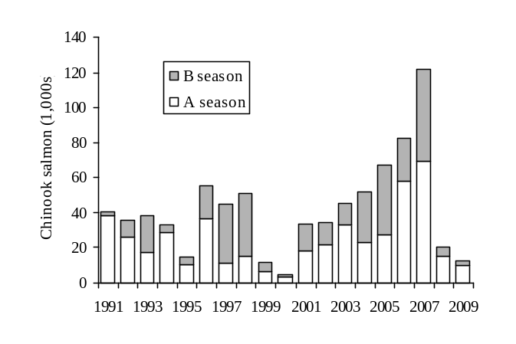
Figure 1. Chinook salmon bycatch in the BSAI pollock mid-water trawl fishery, 1991-2009. (www.fakr.noaa.gov/sustainablefisheries/inseason/chinook_salmon_mortality.pdf)

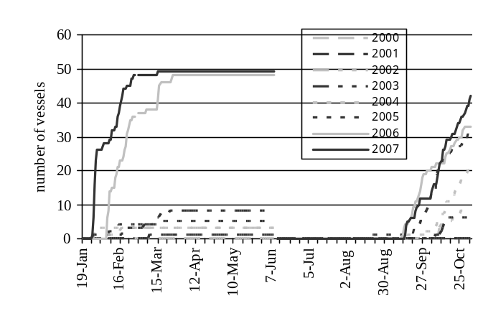
Figure 2. Timing and cumulative numbers of vessels in each season that would have run out of encounter credits under the PPA performance-target cap of 47,591 with no trading and without changes from fishing practices engaged before the introduction of a hard cap. (Inshore sector daily data). Note that some vessels would have run out of credits even in low encounter years (e.g. 2002, 2003).
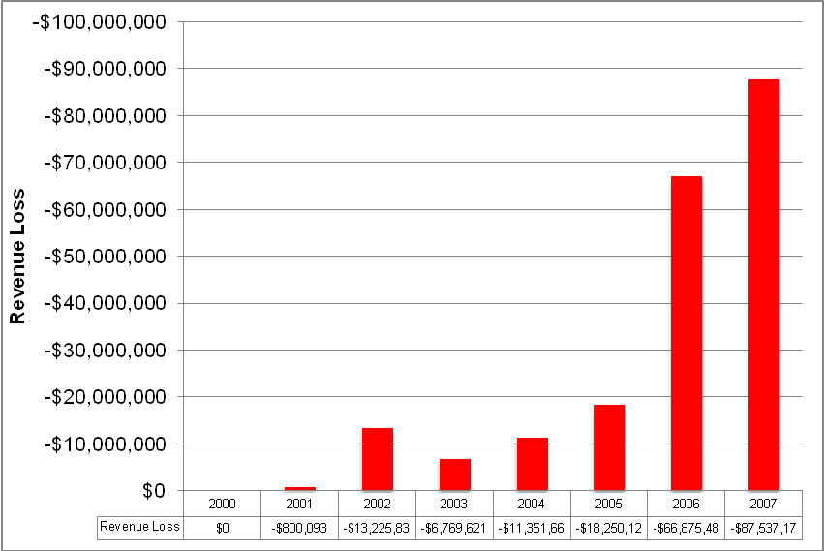
Figure 3. Annual revenue losses for the inshore sector that would have been incurred under the maximum hard cap (60,000 as specified in the PPA) if no reallocation, no trading, and no bycatch avoidance incentives were in place assuming no change in behavior. This calculation is based on daily catch data from Sea State Inc. and the assumption that the ex-vessel A-season price for pollock is $0.20/lb and the B-season price is $0.12/lb.

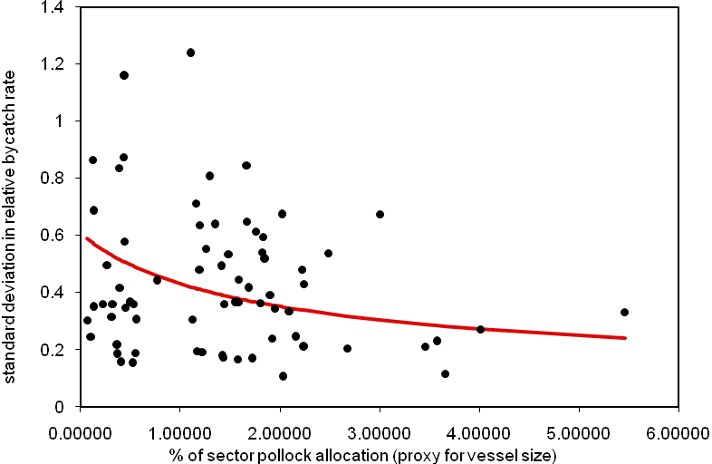
Figure 4. Smaller vessels show higher variability in bycatch rates. (based on annual data)

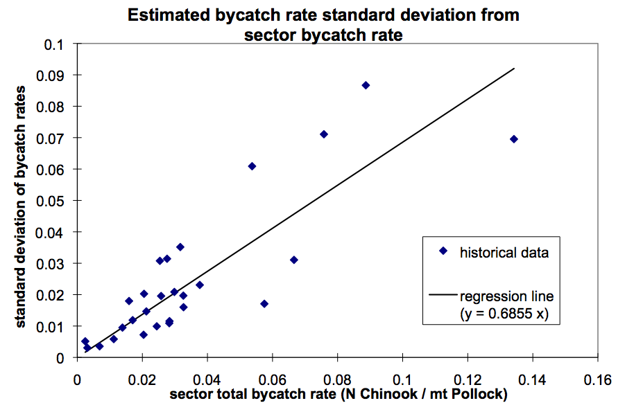
Figure 5. Standard deviation of bycatch rates as a function of sector total bycatch rate. (Annual data from multiple sectors. Provided by Sea State). Narrower distributions of bycatch among vessels accompany lower sector bycatch rates, meaning equivalent actions a lower bycatch levels produce larger effects in ITEC allocation (higher incentives at lower bycatch levels).

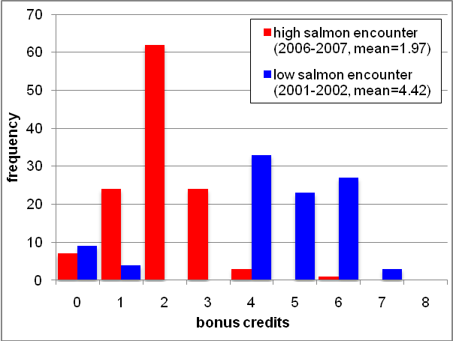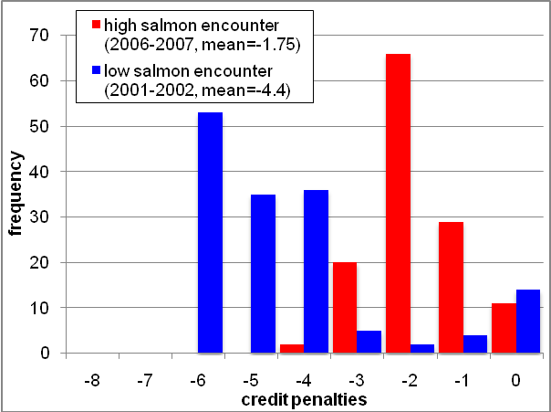
Figure 6. a. Surplus ITEC achievable with 10 fewer Chinook salmon caught using the “equal weight” Legacy Allocation Formula (equation 2) with a linear penalty function. This is analyzed vessel by vessel (based on original annual data). b. Credit penalties (reduced ITEC) as a result of 10 more Chinook salmon caught using the “equal weight” Legacy Allocation Formula (equation 2) with a linear penalty function (based on annual data).

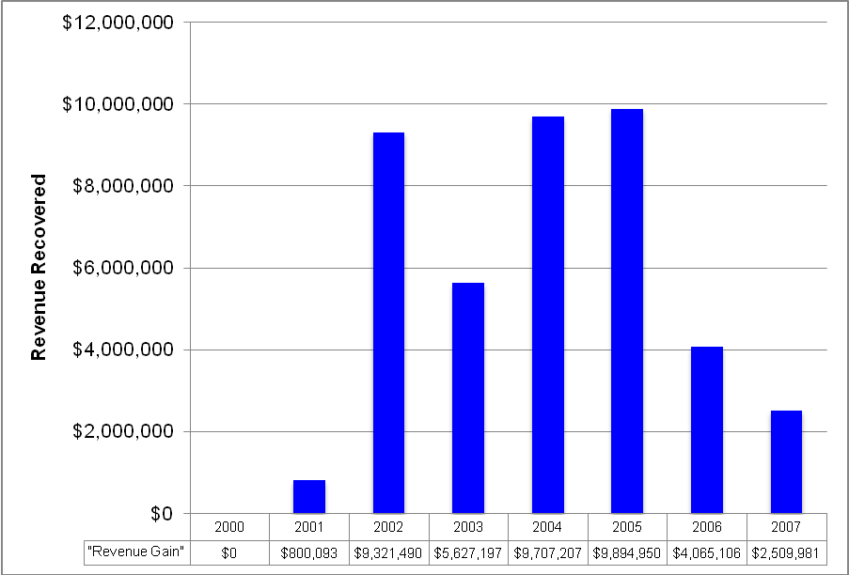
Figure 7. Potential revenue recovered from trading Chinook salmon encounter credits (ITEC’s) under the PPA hard cap. Even without explicit incentives to avoid bycatch, Legacy Reallocation by itself can help to maximize industry revenues. Reallocation assumed “equal weighting” with 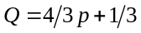 and a linear penalty function.

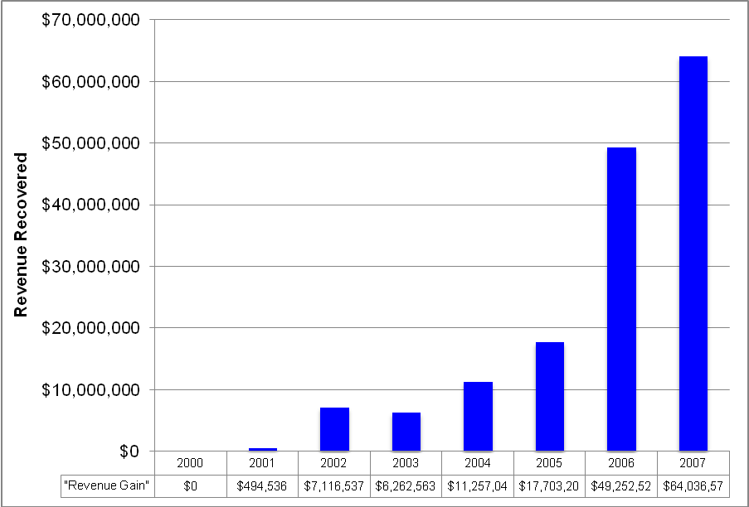
Figure 8. Hypothetical revenue gain (i.e., avoided revenue losses due to unharvested pollock resulting from hitting a hard cap) for the Inshore sector from trading and allocation incentives to avoid bycatch assuming a sector maximum hard cap of 33,390.

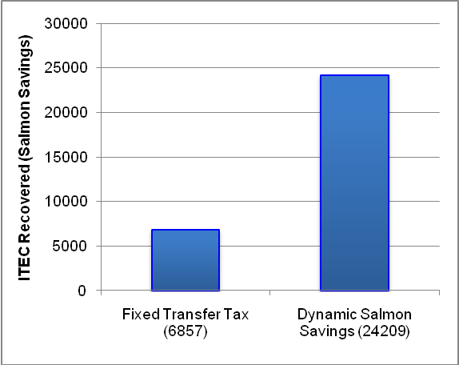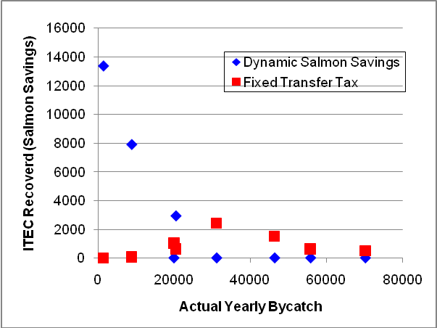
Figure 9. a. Number of retired credits over 8 years (2000 – 2007) under two different sell-side transfer rules: a fixed transfer tax and dynamic salmon savings. b. Number of ITEC recovered vs. yearly bycatch (proxy for salmon abundance) for two different sell-side transfer rules. More ITEC is saved during low salmon abundance years using Dynamic Salmon Savings.

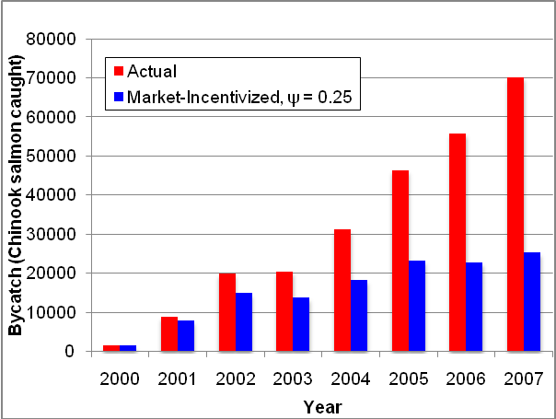
Figure 10. Effects for the Inshore sector of cumulative market incentives for reducing Chinook salmon bycatch under the PPA hard cap.

Appendix A: Technical Issues Regarding the Allocation Formula

Here we examine several technical issues related to the allocation equation:
P_{s, y, i} = α + βP_{s, y-1, i} + γQ_{s, y-1, i} (2)

1) Scaling:
The proportional allocation formula (2) is transformed into number of credits via equation (1):
C_{s, y, i} = P_{s, y, i} F_{s, y, i} I_{s}
where F_{s, y, i} is the AFA cooperative catch share (fraction of the sector’s pollock quota) received by vessel i in season s of year y, and I_{s} is the total amount of ITEC for the sector in season s, as described in the PPA. Because different vessels have different shares of the pollock catch, it is possible for the amount of ITEC distributed within a sector to be different from the sector- and season-appropriate fraction of the target bycatch level of 47,591. In other words, if all smaller vessels fish with lower bycatch rates and larger vessels fish with higher bycatch rates, then the subsequent reallocation will increase the allocation for the smaller vessels and decrease the allocation for the larger vessels by a fractional amount – which is equivalent to a net decrease in allocated credits, since the amount gained by the smaller vessels is lower than the amount lost by the larger vessels. Conversely, a net increase in credit allocation can occur if the larger vessels tend to fish with lower bycatch rates. However, it is highly unlikely for the reallocation to distribute more than 60,000 (the hard cap level)ITEC. In the event of such a rare occurrence, the amount of ITEC to be distributed can simply be scaled to the 60,000 level.

2) Upper and lower bounds for proportional allocations:
When the weightings are such that α = γ the lower and upper bounds on P will depend only on the bounds for Q. Thus, for both equations (3) and (4) the bounds for P are the same [2/3,4/3] when the bounds for Q are [1/3, 5/3] (obtained when Q = 1/3 + 4/3p_{i}). The following bounds for P apply to the following parameter settings for δ and ε in Q: (in order of wide to narrow limits):
[1/2,3/2] Q = 2p_{i}
[2/3,4/3] Q = 1/3 + 4/3p_{i}
[3/4,5/4] Q = 1/2 + p_{i}
When the weightings are α = 0, β = γ = 1 (5), the upper and lower bounds are undefined (independent of the parameters for Q), but can be set arbitrarily as absorbing boundaries to a random walk.

3) Specific forms for the penalty function p:
In general p can be any monotonic function defined on the interval 0 to 1 that rewards low bycatch behavior and that penalizes high bycatch behavior. The performance measure chosen here involves computing a z-score for bycatch rate and converting via linear scaling. Vessels with z < -2 receive a p = 0, and vessels with z > 2 receive a p = 1. Vessels with -2 < z < 2 have p = z/4 + 1/2. Note that this penalty function provides equal incentive for the vast majority of vessels. Here, the incentive is directly related to the slope of the penalty function: a greater slope indicates a greater change in credit reallocation for the same change in bycatch rate.
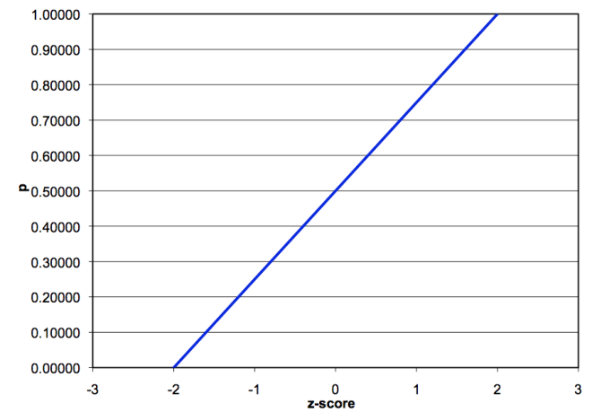
Figure A- . A linear penalty function truncated at z-scores of +2 and -2. Because the slope of the penalty function is equal for all z-scores, all vessels have equal incentive to reduce bycatch regardless of their position in the pack.

An alternative penalty function was considered that uses each vessel’s z-score to compute a cumulative p-value based on a normal distribution. This penalty function would create the highest incentives for most vessels. These vessels near the mean can move up and down in Q value more quickly than vessels at the extremes because of the steepness in the penalty function near the mean. With this form of Q, incentive to improve is large for the most vessels. The main disadvantage is that it exposes the average vessel to more variation.
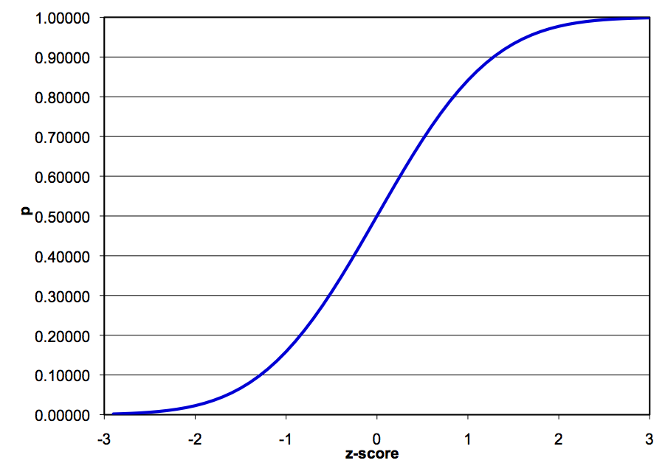
Figure A- . A penalty function computed as the cumulative p-value of the z-score. The slope is highest in the middle; therefore the incentives are largest for vessels in the middle of the pack.

4) Computation of z-scores:
The variance in bycatch rates between vessels can be attributed in part to chance encounters with patchy pockets of Chinook salmon (which is related in part to sample size effects or sampling variation and vessel size), and in part to choices by vessel operators that appear to directly influence bycatch rates (caution in gear deployment, towing speed, choice of fishing location, timing etc).
One reasonable expectation of the CIP is for the distribution of bycatch rates among vessels to decrease over time as vessels exploit the same behavioral changes to reduce bycatch rates. A larger proportion of the variation in bycatch rates would then be due to random chance and not intentional behavior on the part of vessels. Since z-scores are scaled to the standard deviation of the bycatch rates, large fluctuations in z-scores may occur due to random chance. To mitigate this problem, we use an estimated standard deviation based upon a sector-wide bycatch rate (equivalent to a weighted average of individual vessel’s bycatch rates). This calculation is based on historical data across the Inshore Catcher-Vessel sector, the Mothership sector, and the Catcher-Processor sector (Figure 5).
Because small vessels are subject to more sampling error (Figure 4), we also use a corrected standard deviation to reduce the effects of random noise due to vessel size. This random noise varies with the inverse square root of 1 + pollock allocation %. Thus, we correct standard deviation using:
This adjusted standard deviation is then used to calculate the z-score for vessel i:
Note that this calculation for z-score is of the opposite sign of the traditional calculation of z-scores. Thus, high bycatch rates (corresponding to poor performing vessels) map to negative z-scores and low bycatch rates (corresponding to the best performing vessels) map to positive z-scores.

5) Convergence:
The legacy weighting not only affects the magnitude of the variance in credit allocations P, (a smaller γ results in lower year to year variation in P), but it also affects the rate at which one can move in the pack in terms of allocations due to directed behavior. The graphs below (Fig A-3a,b) show the extreme cases realized by the two different weighting schemes: (1/3,1/3,1/3) and (1/4,1/2,1/4).
In the “equal” weighting scheme (1/3,1/3,1/3) the legacy component receives less weight than in the “augmented legacy” weighting scheme (1/4,1/2,1/4), and incentives are increased (larger change in allocations from year-to-year). However, fluctuations in allocation due to random noise affecting bycatch rates are also magnified, which decreases the incentives associated with consistent behavior, and should be taken into account when choosing a weighting system.
A degenerate form of the Legacy Allocation formula (5) creates equal incentive for the same performance regardless of the previous season’s proportional allocation factor. This form has changes in credit proportion computed solely based on the current season’s relative bycatch rate. In order to achieve the same asymptotic bounds of [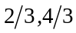], we set hard limits on the values of P, the credit proportion.
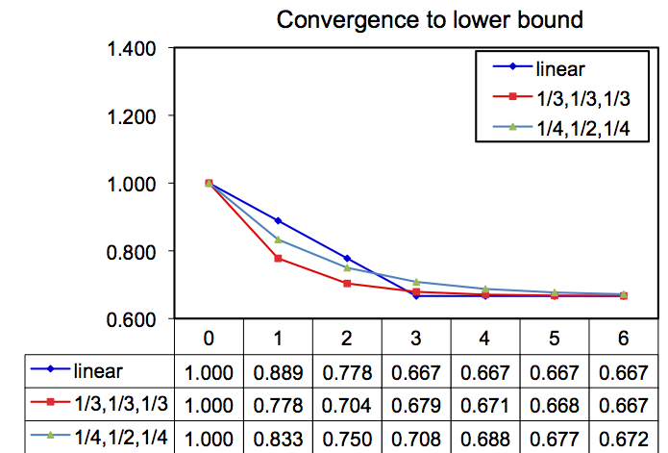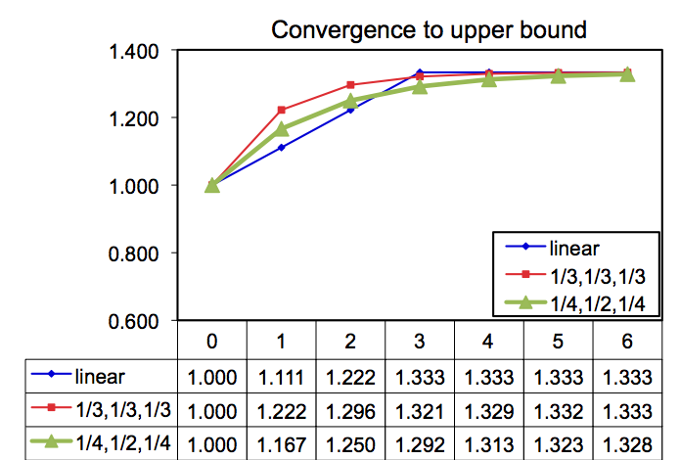
Figure A- 3a. Comparison of two weightings of the legacy component. Assuming p_{i} = 0, worst case. The more heavily weighted legacy component converges slower. b. Comparison of two weightings of the legacy component. Assuming p_{i} = 1, best case. The more heavily weighted legacy component converges slower.

6) Incentives in the False Legacy Model:
The “false legacy allocation” (5) does not contain cumulative incentives to continue improving bycatch rates. To see this, simply notice that having a bycatch rate near the middle of the pack results in no change in proportional allocation (Q = 0). This property poses a problem for vessels that initially do well (have low encounter rates; improving proportional allocation) and then “slack off”: as long as these vessels do not have bycatch rates higher than average, their proportional allocation factor will not decrease.
In addition, because of the fixed upper bound (4/3) on the proportional allocation factor, vessels that are at that upper bound have no incentive to have the lowest bycatch rates. As mentioned earlier, these vessels will not experience a decrease in proportional allocation as long as their bycatch rates are better (i.e., lower) than average.
Perhaps the more problematic issue is those vessels who are at the fixed lower bound (2/3) for the proportional allocation factor. These vessels may actually improve their bycatch rates from what they were before, but will see no change in proportional allocation factor unless they can bring these bycatch rates to be better (i.e., lower) than average. Thus, their incentive to change fishing behavior may be significantly reduced, as only a major change in bycatch rate can alter their position.
Appendix B: Technical Issues Regarding the Fixed Transfer Tax and Dynamic Salmon Savings

1) Fixed Transfer Tax:
With a Fixed Transfer Tax (FTT), a fixed percentage of credits are retired for every ITEC transaction. For our simulation, we used a FTT rate of 20%: if a vessel wished to buy 100 credits, 20% or 20 credits would be retired as the “transfer tax”, so that a total of 120 credits would be removed from a seller’s pool of ITEC, but only 100 would be transferred to the buyer.

2) Dynamic Salmon Savings:
Under a Dynamic Salmon Savings rule, a percentage of a vessel’s remaining credits are retired when that vessel finishes fishing its pollock quota: this percentage is the Salmon Savings Rate (SSR). To prevent vessels from selling credits before finishing fishing and avoiding having credits retired, it is additionally required that vessels who sell credits before finishing fishing reserve the appropriate fraction of credits corresponding to the SSR (or the maximum upper bound on SSR if the SSR has not yet been determined). In our simulation, we used 50% as the maximum upper bound on SSR.

(i) Provisional Salmon Savings Rule:
Note that prior to the completion of fishing and having credits retired based on the SSR, vessels may still transfer credits provided that an appropriate number of credits are set aside to cover eventual retirement. For example, if a cap is set so the largest Salmon Savings Rate is 50% (a number that historically will not limit the harvest), then prior to setting the SSR, boats that have finished fishing early can only sell up to 50% of their remainder credits. This means that if a vessel has wishes to sell 50 credits early in the season, it must keep 50 ITEC in reserve until the SSR has been determined.
Alternatively, if the SSR has been determined to be, say, 20%, vessels that wish to sell credits before fishing the entirety of their pollock allocation must retire an additional 25% credits for each transaction. For example, if that vessel sold 80 credits, it would retire an additional 25% or 20 credits. This fraction is equivalent to applying the SSR of 20% on a vessel that finishes fishing pollock with 100 credits remaining: for this hypothetical vessel, 20 credits would be retired, leaving it with 80 credits to sell, exactly the same as in the example.

(ii) Calculating a savings rate:
Numerical experiments with the Inshore daily data suggest that calculating the savings fraction when 2/3 of the sector pollock quota are caught (2/3 sector TAC) gives the best result, in terms of estimating the credits needed to complete the season. This is the “estimated total sector by-catch for the B-season.” This estimate normally occurs between August 29 and Sept 16 (see figure and table below). This tends to happen later in low salmon abundance years (when fewer transfers are needed) and occurs earlier in moderate to high abundance years.
The “estimated number of surplus credits” in the table below is the (current number of credits for the sector on the date that the salmon savings rate is calculated) - (estimated total B-season bycatch for the sector + buffer). Here the buffer is 5000, to account for error in the estimates of total sector by-catch.
The final “allowable salmon savings rate” would then be (the number of estimated surplus credits) / (current number of credits for the fleet). It is called an” allowable salmon savings rate” in that under this SSR, the pollock harvest for the sector would not be limited by the availability of salmon encounter credits. These numbers are shown in the blue region of the table below. Notice that in high abundance years the SSR is 0% and in low salmon abundance years the allowable SSR can be as high as ~30.0%. That is, in year 2000, we would be confident of fishing the entire pollock quota (with margin for error) if the SSR were set at 30.0%. However such a high rate would put a damper on trading before the rate was posted (albeit, in 2000 no transfers were ultimately necessary).

Table B - . Calculation of SSR for the Inshore Catcher-Vessel sector for years 2000 - 2007
 | Dynamic Salmon Savings Rate (at end of B season) |  |  |  |  |  | Unknown
year | A | B | C | D | E | F | G
2000 | 16-Sep | 9859 | 254 | 7540 | 2319 | 23.52% | 711
2001 | 11-Sep | 9812 | 277 | 7770 | 2042 | 20.8% | 2743
2002 | 5-Sep | 10236 | 1655 | 21550 | (11314) | 0.0% | 9622
2003 | 2-Sep | 10801 | 256 | 7560 | 3241 | 30.0% | 7144
2004 | 31-Aug | 9716 | 1890 | 23900 | (14814) | 0.0% | 20924
2005 | 29-Aug | 9668 | 4142 | 46420 | (25298) | 0.0% | 33734
2006 | 10-Sep | 9703 | 3591 | 40910 | (28728) | 0.0% | 21179
2007 | 2-Sep | 9826 | 1465 | 19650 | (4802) | 0.0% | 33813

A = date when 2/3 pollock caught
B = sector credits remaining (includes 100% carry-forward from A season)
C = bycatch caught (up to the date in A)
D = predicted total bycatch (for season) + buffer (computed as D = 10 C + 5000)
E = estimated surplus credits (computed as E = B – D)
F = allowable salmon savings rate (computed as F = E / B)
G = actual total bycatch (for season)

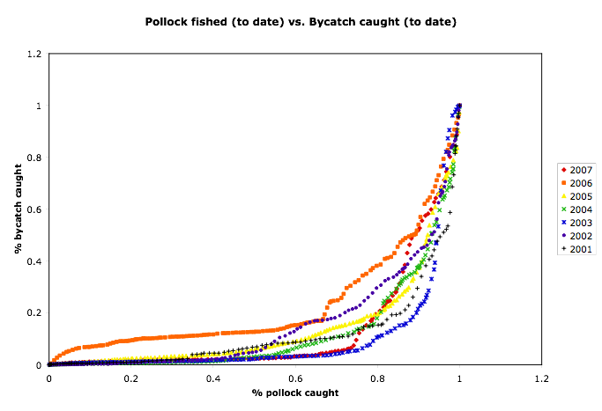

Figure B - . Cumulative bycatch as a function of % pollock harvested during the B season.

- Simulation results:
Annual data for quantities of ITEC retired as a function of annual bycatch (a proxy for salmon abundance) under both the FTT and DSS schemes are shown in Figure 9 and Table B-2. Not only is the total quantity of credits retired through DSS higher for this eight-year period (2000 – 2007), but the quantity of ITEC retired is high in years of low salmon abundance: precisely when the potential for abusing extra ITEC is the highest! Conversely, the quantity of credits retired through FTT is highest in years of intermediate abundance: when the most transactions take place (due to a balance of availability and demand). Increasing the FTT rate to recover more ITEC has the potential of reducing credit transfers in mid-abundance years. The subsequent revenue loss can be extreme if a high FTT rate is chosen.

Table B - . Number of ITEC recovered vs. yearly bycatch (proxy for salmon abundance) for two different sell-side transfer rules.
 | RETIRED CREDITS
Total Bycatch | Fixed Transfer Tax | Dynamic Salmon Savings
1454 | 0 | 13379
8866 | 75 | 7904
19923 | 1034 | 0
20471 | 647 | 2926
31136 | 2436 | 0
46354 | 1521 | 0
55782 | 641 | 0
70148 | 503 | 0

APPENDIX C: Afterthoughts

It may be desirable to allow coops to impose a small 3% tax on all vessel credits allocations to create an Emergency Fund for extreme bad luck cases. This small “emergency fund” could be used to help bail out any vessel that the coop determines had genuine bad luck. Any remainder credits could be put on the market by the coop toward the end of the year to raise revenue. The bad luck event (as deemed by a coop, or better yet a sector) could be incorporated into the legacy system (or not) by adjusting the bycatch rate to not fully reflect this event (say cut the number in half for that tow). This allowance should only happen occasionally per vessel (e.g., once per vessel in 7 years).
Chronic bad players, those with consistently above average bycatch rates can place a drag on the overall performance of the fleet and harm its standing with regard to the Chinook salmon problem. They may be content with the minimal 2/3 allocation and be willing to wait until later in the season when credits could become more available as individual pollock quotas are filled and/or vessels are more comfortable with selling surplus ITEC at low prices. They may not care about the risk that next year may be a moderate to high abundance year, when ITEC will not be readily available, and may be willing to put their businesses at risk. Moreover as discussed, the credits may be uneconomic for the worst players, because they are worth less in terms of expected return on pollock.
One possible way to handle this is to implement a 2-Strikes Rule that suspends credits trading privileges from such repeat offenders in all seasons until they can demonstrate that they can move out of the worst category in any one season. It is ultimately up to the industry to decide the details of this rule and what defines this worst category (e.g., 3 standard deviations below the mean for 2 years running, or near the bottom of the list for 2 years running). Such a rule could quickly weed out the few worst players, and would likely only need to be in effect for some initial period. It has not been implemented in the simulations in the current study.
To summarize, being a chronic offender is risky and uneconomic for several reasons: chronic offenders will tend to run out of credits quickly because of their lower allocation; they will need to buy credits at a price that may not be economic given their high bycatch rates; and, they risk losing trading privileges.

N.B. At present, there are no estimates of Chinook salmon abundance in federal waters off Alaska.
The bycatch rate is the number of Chinook salmon caught per metric ton of pollock.
Dynamic Salmon Savings retires a variable fraction of the excess ITEC remaining after each vessel has completed its pollock harvest, diminishing the supply of tradable credits in low to moderate encounter times.
The reward/penalty occurs in the following year and again in subsequent years with diminishing strength. This reward structure magnifies the incentives associated with reallocation and encourages consistent low bycatch to maximize the number of extra credits.
Note: that when α = γ, the upper and lower bounds on P depend only on the bounds for Q, in this case [1/3, 5/3]. The bounds [2/3, 4/3] for P are the lower and upper bounds recommended here, but these can be adjusted if it is determined by monitoring outcomes that wider/narrower bounds would be more effective.
By sampling variation, we mean the variation in bycatch rates in a hypothetical experiment where two vessels are fishing in the same region at the same time in the same way. These vessels would be expected to have the same bycatch rate. However, a larger vessel is more likely to have a smaller variation in bycatch rate for multiple hauls than a smaller vessel. We do NOT refer to observer coverage of boats: the PPA requires 100% observer coverage for all vessels.
This could be taken as indication that the rule is ineffective, but in reality, simply means that purposefully bad behavior was not observed during years of low salmon encounter: no vessel went out of their way to catch salmon during these years (because there was no incentive to do so). Since this rule is intended to address potential future behavior under a hard cap, we should not find it surprising when it does not affect pollock harvest in a historical simulation.
Here, we discuss a draft version of the SSIP, which is publicly available on the website of the NPFMC. The final version that will be implemented in 2011 may contain revisions that address some of the concerns we outline here.
Consider an example where there are two vessels in the same fishery with multiple bycatch species: vessel 1 is better at avoiding bycatch of species A and vessel 2 is better at avoiding bycatch of species B. The vessels can trade respective ITEC allocation with each other to maximize their catch and balance their bycatch obligations.
It would require that some combination of vessels holding most of the pollock allocation be near the upper bound for P, the proportional allocation factor.

